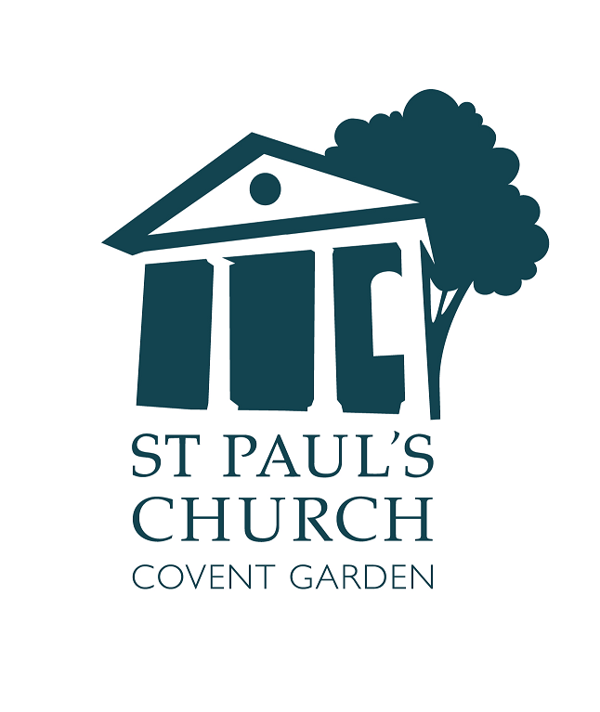
Welcome

The Fourth Sunday of Easter

21 April



actorschurch



St. Paul’s Covent Garden



@actorschurch

Please switch off all mobile phones.
BEWARE: We do occasionally suffer from theft: take care of your belongings
Accessibility
Large Print versions of the Order of Service are available.
Gluten free wafers are available.
Hearing loop installed; collect a receiver from the back of church.
info@actorschurch.org 020 7836 5221 www.actorschurch.org

We stand as the Altar Party enters and sing the hymn
Praise, my soul, the King of heaven;
to his feet thy tribute bring.
Ransomed, healed, restored, forgiven,
who like me his praise should sing?
Praise him! Praise him!
Praise the everlasting King.
2 Praise him for his grace and favour
to our fathers in distress;
praise him still the same for ever,
slow to chide, and swift to bless.
Praise him! Praise him!
Glorious in his faithfulness.
3 Father-like, he tends and spares us;
well our feeble frame he knows;
in his hands he gently bears us,
rescues us from all our foes.
Praise him! Praise him!
Widely as his mercy flows.
4 Angels, help us to adore him;
ye behold him face to face;
sun and moon, bow down before him;
dwellers all in time and space.
Praise him! Praise him!
Praise with us the God of grace.
The Priest goes to the Lectern and says:

Priest In the name of the Father, and of the Son and of the Holy Spirit.
All Amen.
Priest The Lord be with you
All and also with you.
Priest Alleluia, Christ is Risen
All He is Risen indeed. Alleluia.

The priest introduces the service and then leads the congregation in prayer:

Almighty God,
to whom all hearts are open,
all desires known,
and from whom no secrets are hidden:
cleanse the thoughts of our hearts
by the inspiration of your Holy Spirit,
that we may perfectly love you, and worthily magnify your holy name; through Christ our Lord.
Amen.

The priest invites the congregation to seek God’s mercy and grace. We say together:
Almighty God, our heavenly Father,
we have sinned against you
and against our neighbour
in thought and word and deed,
through negligence, through
weakness,
through our own deliberate fault.
We are truly sorry
and repent of all our sins.
For the sake of your Son Jesus
Christ, who died for us,
forgive us all that is past
and grant that we may serve you in
newness of life
to the glory of your name. Amen.

The Priest announces the Absolution to which all reply: Amen. The Gloria is sung from the separate music sheet. The prayer of the day – the Collect – is sung.
Almighty God, whose Son Jesus Christ is the resurrection and the life: raise us, who trust in him, from the death of sin to the life of righteousness, that we may seek those things which are above, where he reigns with you in the unity of the Holy Spirit, one God, now and for ever.
Amen.

We sit for the first and second readings.

First Reading
Acts 4.5-12, read by Max
⁵The Jewish rulers, elders, and scribes assembled in Jerusalem, ⁶with Annas the high priest, Caiaphas, John, and Alexander, and all who were of the high-priestly family. ⁷When they had made the prisoners stand in their midst, they inquired, ‘By what power or by what name did you do this?’ ⁸Then Peter, filled with the Holy Spirit, said to them, ‘Rulers of the people and elders, ⁹if we are questioned today because of a good deed done to someone who was sick and are asked how this man has been healed, ¹⁰let it be known to all of you, and to all the people of Israel, that this man is standing before you in good health by the name of Jesus Christ of Nazareth, whom you crucified, whom God raised from the dead. ¹¹This Jesus is
“the stone that was rejected by you, the builders; it has become the cornerstone.”
¹²There is salvation in no one else, for there is no other name under heaven given among mortals by which we must be saved.’
At the end:
Reader This is the word of the Lord.
All Thanks be to God.

Second Reading
1 John 3.16-24, read by Andrea
¹⁶We know love by this, that he laid down his life for us – and we ought to lay down our lives for one another. ¹⁷How does God’s love abide in anyone who has the world’s goods and sees a brother or sister in need and yet refuses help?
¹⁸Little children, let us love, not in word or speech, but in truth and action. ¹⁹And by this we will know that we are from the truth and will reassure our hearts before him ²⁰whenever our hearts condemn us; for God is greater than our hearts, and he knows everything. ²¹Beloved, if our hearts do not condemn us, we have boldness before God; ²²and we receive from him whatever we ask, because we obey his commandments and do what pleases him.
²³And this is his commandment, that we should believe in the name of his Son Jesus Christ and love one another, just as he has commanded us. ²⁴All who obey his commandments abide in him, and he abides in them. And by this we know that he abides in us, by the Spirit that he has given us.
At the end:
Reader This is the word of the Lord. All Thanks be to God

We stand to sing the hymn and face the Gospel book
The Lord’s my shepherd, I’ll not want;
he makes me down to lie
in pastures green; he leadeth me
the quiet waters by.
2 My soul he doth restore again,
and me to walk doth make
within the paths of righteousness,
e'en for his own name’s sake.
3 Yea, though I walk through death’s dark vale,
yet will I fear none ill;
for thou art with me, and thy rod
and staff me comfort still.
4 My table thou has furnished
in presence of my foes;
my head thou dost with oil anoint,
and my cup overflows.

5 Goodness and mercy all my life
shall surely follow me;
and in God’s house for evermore
my dwelling-place shall be.
All remain standing as the Gospel is read

Priest The Lord be with you
All And also with you
Priest Hear the Gospel of our Lord Jesus Christ according to John (10, 11-18)
All Glory to you, O Lord.
Jesus said to the Pharisees: ¹¹‘I am the good shepherd. The good shepherd lays down his life for the sheep. ¹²The hired hand, who is not the shepherd and does not own the sheep, sees the wolf coming and leaves the sheep and runs away – and the wolf snatches them and scatters them. ¹³The hired hand runs away because a hired hand does not care for the sheep. ¹⁴I am the good shepherd. I know my own and my own know me, ¹⁵just as the Father knows me and I know the Father. And I lay down my life for the sheep. ¹⁶I have other sheep that do not belong to this fold. I must bring them also, and they will listen to my voice. So there will be one flock, one shepherd. ¹⁷For this reason the Father loves me, because I lay down my life in order to take it up again. ¹⁸No one takes it from me, but I lay it down of my own accord. I have power to lay it down, and I have power to take it up again. I have received this command from my Father.’
At the end:
Priest This is the Gospel of the Lord.
All Praise to you, O Christ.

We sit for the Sermon
We stand to say the Creed

We believe in one God,
the Father, the Almighty,
maker of heaven and earth,
of all that is, seen and unseen
We believe in One Lord Jesus Christ
the only Son of God,
eternally begotten of the Father,
God from God, Light from Light,
true God from true God,
begotten, not made,
of one Being with the Father;
through him all things were made.
For us and for our salvation
he came down from heaven,
was incarnate of the Holy Spirit
and the Virgin Mary
and was made man.
For our sake he was crucified
under Pontius Pilate;
he suffered death and was buried.
On the third day he rose again
in accordance with the Scriptures;
he ascended into heaven
and is seated at the right hand of the Father.
He will come again in glory to judge
the living and the dead,
and his kingdom will have no end.
We believe in the Holy Spirit,
the Lord, the giver of life,
who proceeds from the Father and the Son,
who with the Father and the Son
is worshipped and glorified,
who has spoken through the prophets.
We believe in one holy catholic
and apostolic Church.
We acknowledge one baptism
for the forgiveness of sins.
We look for the resurrection of the dead, and the life of the world to come. Amen.

The Prayers of Intercession follow

At the end:
Priest Merciful Father,
All accept these prayers for the sake of your Son, our Saviour, Jesus Christ, Amen.

The Priest introduces the Peace:
Priest: The peace of the Lord be with you always
All And also with you
Priest Let us offer one another a sign of peace.

We sing a hymn as the Altar is prepared for the Eucharistic Prayer. A collection is taken during the hymn
Thine for ever! God of love,
hear us from thy throne above;
thine for ever may we be
here and in eternity.
2 Thine for ever! Lord of life,
shield us through our earthly strife;
thou the life, the truth, the way,
guide us to the realms of day.
3 Thine for ever! O how blest
they who find in thee their rest!
Saviour, guardian, heavenly friend,
O defend us to the end.
4 Thine for ever! Shepherd, keep
us thy frail and trembling sheep;
safe alone beneath thy care,
let us all thy goodness share.
5 Thine for ever! Thou our guide,
all our wants by thee supplied,
all our sins by thee forgiven,
lead us, Lord, from earth to heaven.

Priest Blessed are you Lord God of
all creation. Through your goodness we have this bread to offer, which earth has given and human hands have made. It will become for us the bread of life.
All Blessed be God for ever
Priest Blessed are you Lord God of all creation. Through your goodness we have this wine to offer. Fruit of the vine and work of human hands, it will become our spiritual drink
All Blessed be God for ever
Priest Pray my sisters and brothers that our sacrifice may be acceptable to God the Almighty Father
All May the Lord accept the sacrifice at your hand, for the praise and glory of his name, for our good and the good of all his Church.

The Priest adds the prayer over the gifts to which we reply Amen
Priest The Lord be with you
All And also with you.
Priest Lift up your hearts.
All We lift them to the Lord.
Priest Let us give thanks to the Lord our God.
All It is right to give thanks and praise...

The Eucharistic Prayer continues until we sing Sanctus and Benedictus from the music sheet

The Eucharistic Prayer continues until…
Priest: Great is the mystery of faith
All: Christ has died
Christ is risen
Christ will come again
The Eucharistic Prayer continues until
Priest …for ever and ever
All: Amen
Priest: As our Saviour taught us, so we pray:
Our Father, who art in heaven
hallowed be thy name
Thy kingdom come, thy will be done
on earth as it is in heaven
Give us this day our daily bread
and forgive us our trespasses
as we forgive those who trespass against us
And lead us not into temptation
but deliver us from evil
For thine is the kingdom
the power and the glory
for ever and ever. Amen

Priest We break this bread to share in the body of Christ
All Though we are many we are one body, because we all share in one bread

The Agnus Dei is sung from the music sheet

Priest Jesus is the Lamb of God who takes away the sin of the world, blessed are those who are called to his supper.
All Lord, I am not worthy to receive you,
but only say the word, and I shall be healed.
The congregation approaches the altar to receive Communion. All those who are in good standing with their own Church are invited to receive Communion.
Those who prefer to ask for a Blessing are invited to bow their heads at the Altar rail, or bring this booklet as a sign for the Priest
Please make your way to the Altar rail, and kneel (if able)
Please receive Communion in your hand ONLY. If you do not wish to receive the Chalice, please return to your place.
Please keep absolute silence during Communion

After Communion we remain seated to sing the hymn
Loving shepherd of thy sheep,
keep thy lamb, in safety keep;
nothing can thy power withstand,
none can pluck me from thy hand.
2 Loving Saviour, thou didst give
thine own life that we might live,
and the hands outstretched to bless
bear the cruel nails’ impress.
3 I would praise thee every day,
gladly all thy will obey,
like thy blessed ones above
happy in thy precious love.
4 Loving shepherd, ever near,
teach thy lamb thy voice to hear;
suffer not my steps to stray
from the straight and narrow way.
5 Where thou leadest I would go,
walking in thy steps below,
till before my Father’s throne
I shall know as I am known.
Post Communion Prayers:
Merciful Father, you gave your Son Jesus Christ to be the good shepherd,
and in his love for us to lay down his life and rise again: keep us always under his protection, and give us grace to follow in his steps; through Jesus Christ our Lord.
Amen
We say together:
Almighty God,
we thank you for feeding us
with the body and blood of your Son Jesus Christ.
Through him we offer you our souls and bodies
to be a living sacrifice.
Send us out
in the power of your Spirit
to live and work
to your praise and glory.
Amen.

Any Banns of marriage and notices are given.
and then the Priest says:

Priest The Lord be with you
All And also with you

The Blessing is given to which all reply: Amen
We sing the hymn and turn to face the West End for the dismissal
Jesus lives! Thy terrors now
can no more, O death, appal us;
Jesus lives! By this we know
thou, O grave, canst not enthral us.
Alleluia!
2 Jesus lives! Henceforth is death
but the gate of life immortal:
this shall calm our trembling breath,
when we pass its gloomy portal.
Alleluia!
3 Jesus lives! For us he died;
then, alone to Jesus living,
pure in heart may we abide,
glory to our Saviour giving.
Alleluia!
4 Jesus lives! Our hearts know well
naught from us his love shall sever;
life nor death nor powers of hell
tear us from his keeping ever.
Alleluia!
5 Jesus lives! To him the throne
over all the world is given:
may we go where he is gone,
rest and reign with him in heaven.
Alleluia!

Priest. Go in peace to love and serve the Lord, Alleluia, Alleluia
All Thanks be to God, Alleluia, Alleluia.

‘What’s On’ this week

Wednesday 24 April
12.00 Sandwich Lunch in church – all Welcome
1.10pm Holy Eucharist

Friday 26 April
7.30pm Timeless Sonatas **

Saturday 27 April
6.30pm & 8.30pm Musicals by Candlelight **

Sunday 28 April
11.00 Parish Sung Eucharist
for the Fifth Sunday of Easter
12.15pm Annual Parochial Church Meeting

** Tickets for all paid events at St. Paul’s can be obtained via our website www.actorschurch.org

