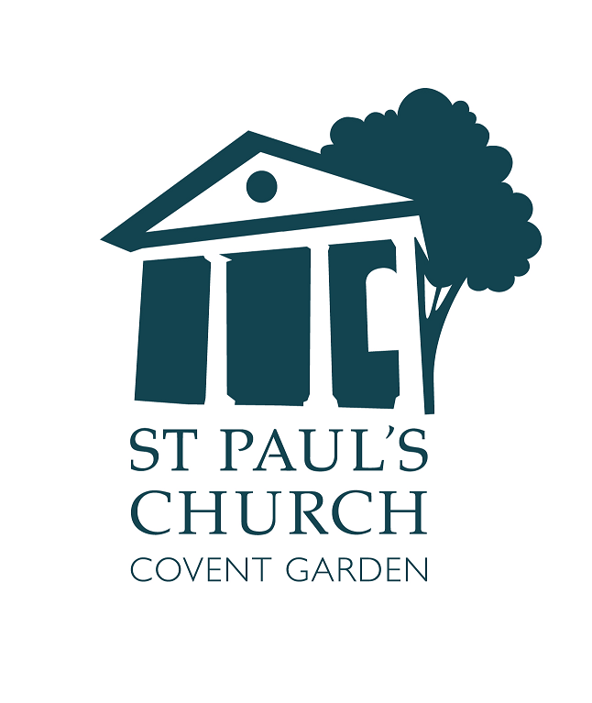
Welcome

The Third Sunday of Easter

14 April



actorschurch



St. Paul’s Covent Garden



@actorschurch

Please switch off all mobile phones.
BEWARE: We do occasionally suffer from theft: take care of your belongings
Accessibility
Large Print versions of the Order of Service are available.
Gluten free wafers are available.
Hearing loop installed; collect a receiver from the back of church.
info@actorschurch.org 020 7836 5221 www.actorschurch.org

We stand as the Altar Party enters and sing the hymn
Alleluia! Sing to Jesus!
His the sceptre, his the throne;
alleluia! His the triumph,
his the victory alone:
hark! The songs of peaceful Sion
thunder like a mighty flood;
Jesus out of every nation
hath redeemed us by his blood.
2 Alleluia! Not as orphans
are we left in sorrow now;
alleluia! He is near us,
faith believes, nor questions how:
though the cloud from sight received him,
when the forty days were o’er,
shall our hearts forget his promise,
“I am with you evermore”?
3 Alleluia! Bread of angels,
thou on earth our food, our stay;
alleluia! Here the sinful
flee to thee from day to day:
intercessor, friend of sinners,
earth’s Redeemer, plead for me,
where the songs of all the sinless
sweep across the crystal sea.
4 Alleluia! King eternal,
thee the Lord of Lords we own;
alleluia! Born of Mary,
earth thy footstool, heaven thy throne:
thou within the veil hast entered,
robed in flesh, our great high priest;
thou on earth both priest and victim
in the Eucharistic feast.
The Priest goes to the Lectern and says:

Priest In the name of the Father, and of the Son and of the Holy Spirit.
All Amen.
Priest The Lord be with you
All and also with you.
Priest Alleluia, Christ is Risen
All He is Risen indeed. Alleluia.

The priest introduces the service and then leads the congregation in prayer:
Almighty God,
to whom all hearts are open,
all desires known,
and from whom no secrets are hidden:
cleanse the thoughts of our hearts
by the inspiration of your Holy Spirit,
that we may perfectly love you, and worthily magnify your holy name; through Christ our Lord.
Amen.

The priest invites the congregation to seek God’s mercy and grace. We say together:
Almighty God, our heavenly Father,
we have sinned against you
and against our neighbour
in thought and word and deed,
through negligence, through
weakness,
through our own deliberate fault.
We are truly sorry
and repent of all our sins.
For the sake of your Son Jesus
Christ, who died for us,
forgive us all that is past
and grant that we may serve you in
newness of life
to the glory of your name. Amen.

The Priest announces the Absolution to which all reply: Amen. The Gloria is sung from the separate music sheet. The prayer of the day – the Collect – is sung.

Almighty Father, who in your great mercy gladdened the disciples with the sight of the risen Lord: give us such knowledge of his presence with us, that we may be strengthened and sustained by his risen life
and serve you continually in righteousness and truth; through Jesus Christ your Son our Lord, who is alive and reigns with you,
in the unity of the Holy Spirit, one God, now and for ever. Amen.

We sit for the first and second readings.
First Reading
Acts 3.12-19, read by Josephine
¹²Peter addressed the people, ‘You Israelites, why do you wonder at this, or why do you stare at us, as though by our own power or piety we had made him walk? ¹³The God of Abraham, the God of Isaac, and the God of Jacob, the God of our ancestors has glorified his servant Jesus, whom you handed over and rejected in the presence of Pilate, though he had decided to release him. ¹⁴But you rejected the Holy and Righteous One and asked to have a murderer given to you, ¹⁵and you killed the Author of life, whom God raised from the dead. To this we are witnesses. ¹⁶And by faith in his name, his name itself has made this man strong, whom you see and know; and the faith that is through Jesus has given him this perfect health in the presence of all of you.
¹⁷‘And now, friends, I know that you acted in ignorance, as did also your rulers. ¹⁸In this way God fulfilled what he had foretold through all the prophets, that his Messiah would suffer. ¹⁹Repent therefore, and turn to God so that your sins may be wiped out.’
At the end:
Reader This is the word of the Lord.
All Thanks be to God.

Second Reading
1 John 3.1-7, read by Jennifer
¹See what love the Father has given us, that we should be called children of God; and that is what we are. The reason the world does not know us is that it did not know him. ²Beloved, we are God’s children now; what we will be has not yet been revealed. What we do know is this: when he is revealed, we will be like him, for we will see him as he is. ³And all who have this hope in him purify themselves, just as he is pure.
⁴Everyone who commits sin is guilty of lawlessness; sin is lawlessness. ⁵You know that he was revealed to take away sins, and in him there is no sin. ⁶No one who abides in him sins; no one who sins has either seen him or known him. ⁷Little children, let no one deceive you. Everyone who does what is right is righteous, just as he is righteous.
At the end:
Reader This is the word of the Lord. All Thanks be to God

We stand to sing the hymn and face the Gospel book

Father of heaven, whose love profound
a ransom for our souls hath found,
before thy throne we sinners bend,
to us thy pardoning love extend.
2 Almighty Son, incarnate Word,
our prophet, priest, Redeemer, Lord,
before thy throne we sinners bend,
to us thy saving grace extend.
3 Eternal Spirit, by whose breath
the soul is raised from sin and death,
before thy throne we sinners bend,
to us thy quickening power extend.
4 Thrice Holy! Father, Spirit, Son;
mysterious Godhead, three in one,
before thy throne we sinners bend,
grace, pardon, life to us extend.
All remain standing as the Gospel is read

Priest The Lord be with you
All And also with you
Priest Hear the Gospel of our Lord Jesus Christ according to Luke (24.36b-48)
All Glory to you, O Lord.
³⁶While the eleven and their companions were talking about what they had heard, Jesus himself stood among them and said to them, ‘Peace be with you.’ ³⁷They were startled and terrified, and thought that they were seeing a ghost. ³⁸He said to them, ‘Why are you frightened, and why do doubts arise in your hearts? ³⁹Look at my hands and my feet; see that it is I myself. Touch me and see; for a ghost does not have flesh and bones as you see that I have.’ ⁴⁰And when he had said this, he showed them his hands and his feet. ⁴¹While in their joy they were disbelieving and still wondering, he said to them, ‘Have you anything here to eat?’ ⁴²They gave him a piece of broiled fish, ⁴³and he took it and ate in their presence.
⁴⁴Then he said to them, ‘These are my words that I spoke to you while I was still with you - that everything written about me in the law of Moses, the prophets, and the psalms must be fulfilled.’ ⁴⁵Then he opened their minds to understand the scriptures, ⁴⁶and he said to them, ‘Thus it is written, that the Messiah is to suffer and to rise from the dead on the third day, ⁴⁷and that repentance and forgiveness of sins is to be proclaimed in his name to all nations, beginning from Jerusalem. ⁴⁸You are witnesses of these things.’
At the end:
Priest This is the Gospel of the Lord.
All Praise to you, O Christ.

We sit for the Sermon
We stand to say the Creed

We believe in one God,
the Father, the Almighty,
maker of heaven and earth,
of all that is, seen and unseen
We believe in One Lord Jesus Christ
the only Son of God,
eternally begotten of the Father,
God from God, Light from Light,
true God from true God,
begotten, not made,
of one Being with the Father;
through him all things were made.
For us and for our salvation
he came down from heaven,
was incarnate of the Holy Spirit
and the Virgin Mary
and was made man.
For our sake he was crucified
under Pontius Pilate;
he suffered death and was buried.
On the third day he rose again
in accordance with the Scriptures;
he ascended into heaven
and is seated at the right hand of the Father.
He will come again in glory to judge
the living and the dead,
and his kingdom will have no end.
We believe in the Holy Spirit,
the Lord, the giver of life,
who proceeds from the Father and the Son,
who with the Father and the Son
is worshipped and glorified,
who has spoken through the prophets.
We believe in one holy catholic
and apostolic Church.

We acknowledge one baptism
for the forgiveness of sins.
We look for the resurrection of the dead, and the life of the world to come. Amen.

The Prayers of Intercession follow
At the end:
Priest Merciful Father,
All accept these prayers for the sake of your Son, our Saviour, Jesus Christ, Amen.

The Priest introduces the Peace:
Priest: The peace of the Lord be with you always
All And also with you
Priest Let us offer one another a sign of peace.

We sing a hymn as the Altar is prepared for the Eucharistic Prayer. A collection is taken during the hymn
Crown him with many crowns,
the lamb upon his throne;
hark! how the heavenly anthem drowns
all music but its own:
awake, my soul, and sing
of him who died for thee,
and hail him as thy matchless King
through all eternity.
2 Crown him the virgin’s Son,
the God incarnate born,
whose arm those crimson trophies won
which now his brow adorn:
fruit of the mystic rose,
as of that rose the stem;
the root whence mercy ever flows,
the babe of Bethlehem.
3 Crown him the Lord of love!
Behold his hands and side,
rich wounds yet visible above
in beauty glorified:
no angel in the sky
can fully bear that sight,
but downward bends his burning eye
at mysteries so bright.
4 Crown him the Lord of peace,
whose power a sceptre sways
from pole to pole, that wars may cease,
absorbed in prayer and praise:
his reign shall know no end,
and round his pierced feet
fair flowers of Paradise extend
their fragrance ever sweet.
5 Crown him the Lord of years,
the potentate of time,
creator of the rolling spheres,
ineffably sublime.
Glassed in a sea of light,
where everlasting waves
reflect his throne - the infinite!
who lives - and loves - and saves.
Priest Blessed are you Lord God of
all creation. Through your goodness we have this bread to offer, which earth has given and human hands have made. It will become for us the bread of life.
All Blessed be God for ever
Priest Blessed are you Lord God of all creation. Through your goodness we have this wine to offer. Fruit of the vine and work of human hands, it will become our spiritual drink
All Blessed be God for ever
Priest Pray my sisters and brothers that our sacrifice may be acceptable to God the Almighty Father
All May the Lord accept the sacrifice at your hand, for the praise and glory of his name, for our good and the good of all his Church.

The Priest adds the prayer over the gifts to which we reply Amen
Priest The Lord be with you
All And also with you.
Priest Lift up your hearts.
All We lift them to the Lord.
Priest Let us give thanks to the Lord our God.
All It is right to give thanks and praise...

The Eucharistic Prayer continues until we sing Sanctus and Benedictus from the music sheet

The Eucharistic Prayer continues until…
Priest: Great is the mystery of faith
All: Christ has died
Christ is risen
Christ will come again

The Eucharistic Prayer continues until
Priest …for ever and ever
All: Amen

Priest: As our Saviour taught us, so we pray:
Our Father, who art in heaven
hallowed be thy name
Thy kingdom come, thy will be done
on earth as it is in heaven
Give us this day our daily bread
and forgive us our trespasses
as we forgive those who trespass against us
And lead us not into temptation
but deliver us from evil
For thine is the kingdom
the power and the glory
for ever and ever. Amen

Priest We break this bread to share in the body of Christ
All Though we are many we are one body, because we all share in one bread

The Agnus Dei is sung from the music sheet

Priest Jesus is the Lamb of God who takes away the sin of the world, blessed are those who are called to his supper.
All Lord, I am not worthy to receive you,
but only say the word, and I shall be healed.
The congregation approaches the altar to receive Communion. All those who are in good standing with their own Church are invited to receive Communion.
Those who prefer to ask for a Blessing are invited to bow their heads at the Altar rail, or bring this booklet as a sign for the Priest
Please make your way to the Altar rail, and kneel (if able)
Please receive Communion in your hand ONLY. If you do not wish to receive the Chalice, please return to your place.
Please keep absolute silence during Communion

After Communion we remain seated to sing the hymn
He is Lord, he is Lord,
he is risen from the dead
and he is Lord.
Ev’ry knee shall bow,
ev’ry tongue confess
that Jesus Christ is Lord.
He is King….etc
He is Love….ect

Post Communion Prayers:
Living God, your Son made himself known to his disciples in the breaking of bread:
open the eyes of our faith, that we may see him in all his redeeming work;
who is alive and reigns, now and for ever.
Amen
We say together:
Almighty God,
we thank you for feeding us
with the body and blood of your Son Jesus Christ.
Through him we offer you our souls and bodies
to be a living sacrifice.
Send us out
in the power of your Spirit
to live and work
to your praise and glory.
Amen.

Any Banns of marriage and notices are given.
and then the Priest says:

Priest The Lord be with you
All And also with you

The Blessing is given to which all reply: Amen
We sing the hymn and turn to face the West End for the dismissal

Alleluia! Alleluia!
Hearts to heaven and voices raise;
sing to God a hymn of gladness,
sing to God a hymn of praise:
he who on the cross a victim
for the world’s salvation bled,
Jesus Christ, the King of glory,
now is risen from the dead.
2 Christ is risen, Christ the first-fruits
of the holy harvest field,
which will all its full abundance
at his second coming yield;
then the golden ears of harvest
will their heads before him wave,
ripened by his glorious sunshine,
from the furrows of the grave.
3 Christ is risen, we are risen;
shed upon us heavenly grace,
rain, and dew, and gleams of glory
from the brightness of thy face;
that we, with our hearts in heaven,
here on earth may fruitful be,
and by angel-hands be gathered,
and be ever, Lord, with thee.
4 Alleluia! Alleluia!
Glory be to God on high;
alleluia to the Saviour,
who has gained the victory;
alleluia to the Spirit,
fount of love and sanctity;
Alleluia! Alleluia!
To the triune majesty.

Priest. Go in peace to love and serve the Lord, Alleluia, Alleluia
All Thanks be to God, Alleluia, Alleluia.

‘What’s On’ this week

Today
4pm Choral Evensong, with the choir of St. Paul’s.

Wednesday 17 April
12.00 Sandwich Lunch in church – all Welcome
1.10pm Holy Eucharist
7pm PCC meeting, in the Rectory Flat

Friday 19 April
1.30pm Funeral of the late Jinnie Kleboe RIP
6.30pm & 8.30pm Musicals by Candlelight **

Saturday 20 April
6.30pm & 8.30pm Musicals by Candlelight **

Sunday 21 April
11.00 Parish Sung Eucharist
for the Fourth Sunday of Easter
Please note that the London Marathon takes place today, and you may need to adjust your route to get to Church.

Annual Parochial Church Meeting
Please note that the APCM will take place immediately after the Eucharist on Sunday 28 April. Please make every effort to attend this important meeting. We will, once again, try to break the record for the shortest APCM in the Church of England.

** Tickets for all paid events at St. Paul’s can be obtained via our website www.actorschurch.org

