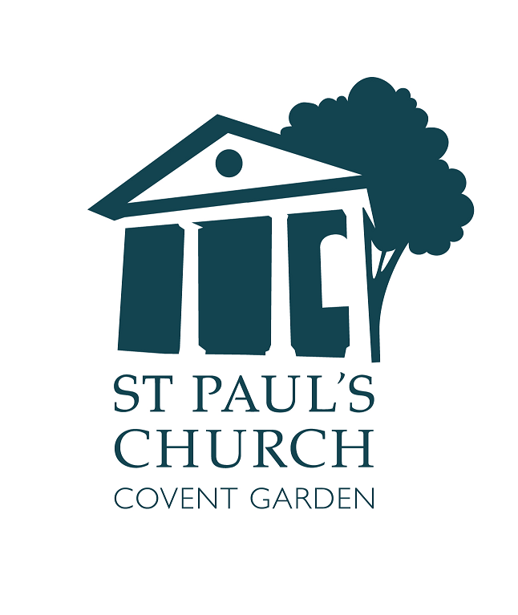
Welcome

PALM SUNDAY

24 March



actorschurch



St. Paul’s Covent Garden



@actorschurch

Please switch off all mobile phones.
BEWARE: We do occasionally suffer from theft: take care of your belongings
Accessibility
Large Print versions of the Order of Service are available.
Gluten free wafers are available.
Hearing loop installed; collect a receiver from the back of church.
info@actorschurch.org 020 7836 5221 www.actorschurch.org

We gather in the South Chapel for the Blessing of the Palms. The Priest introduces the service and we listen to the Antiphon.

Hosanna to the Son of David
Blessed is he who comes in the name of the Lord
O King of Israel,
Hosanna in the highest.

We hold up our Palms for them to be blessed and sprinkled with Holy Water. We listen to the reading of the Palm Sunday Gospel

Priest The Lord be with you

All And also with you
Priest Hear the Gospel of our Lord Jesus Christ according to Mark
All Glory to you, O Lord.
At the end:
Priest This is the Gospel of the Lord.
All Praise to you, O Christ.
Priest Let us go forth, praising Jesus our Messiah

We sing the hymn and process up the south aisle and down the centre aisle to our places.
Refrain:
1. All glory, laud, and honour
to thee, Redeemer, King!
to whom the lips of children
made sweet hosannas ring.
2. Thou art the King of Israel,
thou David's royal Son,
who in the Lord's Name comest,
the King and Blessed One. Refrain
3. The company of angels
are praising thee on high;
and mortal men and all things
created make reply. Refrain
4. The people of the Hebrews
with palms before thee went;
our praise and prayer and anthems
before thee we present. Refrain
5. To thee before thy passion
they sang their hymns of praise;
to thee, now high exalted,
our melody we raise. Refrain
6. Thou didst accept their praises;
accept the prayers we bring,
who in all good delightest,
thou good and gracious King. Refrain
The prayer of the day – the Collect – is said:
Almighty and everlasting God,
who in your tender love towards the human race sent your Son our Saviour Jesus Christ to take upon him our flesh
and to suffer death upon the cross:
grant that we may follow the example of his patience and humility, and also be made partakers of his resurrection; through Jesus Christ your Son our Lord, who is alive and reigns with you,
in the unity of the Holy Spirit,
one God, now and for ever.
Amen.

We sit for the first and second readings.
First Reading
Isaiah 50.4-9a, read by Rob
The servant of the LORD said:
⁴The Lord GOD has given me
the tongue of a teacher,
that I may know how to sustain
the weary with a word.
Morning by morning he wakens –
wakens my ear to listen as those who are taught.
⁵The Lord GOD has opened my ear,
and I was not rebellious,
I did not turn backwards.
⁶I gave my back to those who struck me,
and my cheeks to those who pulled out the beard;
I did not hide my face from insult and spitting.
⁷The Lord GOD helps me;
therefore I have not been disgraced;
therefore I have set my face like flint,
and I know that I shall not be put to shame;
⁸he who vindicates me is near.
Who will contend with me?
Let us stand up together.
Who are my adversaries?
Let them confront me.
⁹It is the Lord GOD who helps me;
who will declare me guilty?
All of them will wear out like a garment;
the moth will eat them up.
At the end:
Reader This is the word of the Lord.
All Thanks be to God.

Second Reading
Philippians 2.5-11, read by Tony
⁵Let the same mind be in you that was in Christ Jesus, ⁶who, though he was in the form of God, did not regard equality with God as something to be exploited,
⁷but emptied himself, taking the form of a slave, being born in human likeness.
And being found in human form,
⁸he humbled himself and became obedient to the point of death – even death on a cross.
⁹Therefore God also highly exalted him
and gave him the name that is above every name, ¹⁰so that at the name of Jesus
every knee should bend, in heaven and on earth and under the earth, ¹¹and every tongue should confess that Jesus Christ is Lord, to the glory of God the Father.
At the end:
Reader This is the word of the Lord. All Thanks be to God.
We stand to sing the hymn and turn towards the Gospel book

1. Ride on! ride on in majesty!
Hark! all the tribes hosanna cry;
O Saviour meek, pursue thy road
with palms and scattered garments strowed.
2. Ride on! ride on in majesty!
In lowly pomp ride on to die;
O Christ, thy triumphs now begin
o'er captive death and conquered sin.
3. Ride on! ride on in majesty!
The angel-squadrons of the sky
look down with sad and wondering eyes
to see the approaching sacrifice.
4. Ride on! ride on in majesty!
Thy last and fiercest strife is nigh;
the Father on his sapphire throne
expects his own anointed Son.
5. Ride on! ride on in majesty!
In lowly pomp ride on to die;
bow thy meek head to mortal pain,
then take, O God, thy power, and reign.
All remain standing as the Gospel is read dramatically – please join in the parts marked C: on the separate sheet
We sit for the Sermon

We stand to say the Creed

We believe in one God,
the Father, the Almighty,
maker of heaven and earth,
of all that is, seen and unseen
We believe in One Lord Jesus Christ the only Son of God,
eternally begotten of the Father,
God from God, Light from Light,
true God from true God,
begotten, not made,
of one Being with the Father;
through him all things were made.
For us and for our salvation
he came down from heaven,
was incarnate of the Holy Spirit
and the Virgin Mary
and was made man.
For our sake he was crucified
under Pontius Pilate;
he suffered death and was buried.
On the third day he rose again
in accordance with the Scriptures;
he ascended into heaven
and is seated at the right hand of the Father.
He will come again in glory to judge the living and the dead,
and his kingdom will have no end.
We believe in the Holy Spirit,
the Lord, the giver of life,
who proceeds from the Father and the Son,
who with the Father and the Son
is worshipped and glorified,
who has spoken through the prophets.
We believe in one holy catholic
and apostolic Church.
We acknowledge one baptism
for the forgiveness of sins.
We look for the resurrection of the dead, and the life of the world to come. Amen.

The Prayers of Intercession follow
At the end:

Priest Merciful Father,
All accept these prayers for the sake of your Son, our Saviour, Jesus Christ, Amen.
The Priest introduces the Peace:
Priest: The peace of the Lord be with you always
All And also with you
Priest Let us offer one another a sign of peace.
We sing a hymn as the Altar is prepared for the Eucharistic Prayer. A collection is taken during the hymn
1. I cannot tell why he, whom angels worship,
should set his love upon the sons of men,
or why, as Shepherd, he should seek the wanderers,
to bring them back, they know not how or when.
But this I know, that he was born of Mary,
when Bethlehem’s manger was his only home,
and that he lived at Nazareth and laboured,
and so the Saviour, Saviour of the world, is come.
2. I cannot tell how silently he suffered,
as with his peace he graced this place of tears,
or how his heart upon the cross was broken,
the crown of pain to three-and-thirty years.
But this I know, he heals the broken-hearted,
and stays our sin, and calms our lurking fear,
and lifts the burden from the heavy-laden,
for yet the Saviour, Saviour of the world, is here.
3. I cannot tell how he will win the nations,
how he will claim his earthly heritage,
how satisfy the needs and aspirations
of east and west, of sinner and of sage.
But this I know, all flesh shall see his glory,
and he shall reap the harvest he has sown,
and some glad day his sun shall shine in splendour,
when he the Saviour, Saviour of the world is known.
4. I cannot tell how all the lands shall worship,
when, at his bidding, every storm is stilled,
or who can say how great the jubilation
when all the hearts of men with love are filled.
But this I know, the skies will thrill with rapture,
and myriad, myriad human voices sing,
and earth to heaven, and heaven to earth, will answer:
“At last the Saviour, Saviour of the world, is King!”

Priest Blessed are you Lord God of all creation. Through your goodness we have this bread to offer which earth has given and human hands have made. It will become for us the bread of life
All Blessed be God for ever

Priest Blessed are you Lord God of all creation. Through your goodness we have this wine to offer. Fruit of the vine and work of human hands, it will become our spiritual drink
All Blessed be God for ever
Priest Pray my brothers and sisters that our sacrifice may be acceptable to God the Almighty Father
All May the Lord accept the sacrifice at your hand, for the praise and glory of his name, for our good and the good of all his Church.

The Priest adds the prayer over the gifts to which we reply Amen

Priest The Lord be with you
All And also with you.
Priest Lift up your hearts.
All We lift them to the Lord.
Priest Let us give thanks to the Lord our God.
All It is right to give thanks and praise...

The Eucharistic Prayer continues until we sing the Sanctus and Benedictus from the music sheet. The Eucharistic Prayer continues until…
Priest Great is the mystery of faith

All Dying, you destroyed our death
Rising you restored our life
Lord Jesus, come in glory

The Eucharistic Prayer continues until
Priest …for ever and ever
All Amen

Priest As our Saviour taught us, so
we pray:
Our Father, who art in heaven
Hallowed be thy name
Thy kingdom come, thy will be done
On earth as it is in heaven
Give us this day our daily bread
And forgive us our trespasses
As we forgive those who trespass against us
And lead us not into temptation
But deliver us from evil
For thine is the kingdom
The power and the glory
for ever and ever. Amen

Priest We break this bread to share in the body of Christ
All Though we are many we are one body, because we all share in one bread

We sing the Agnus Dei from the music sheet.
Priest Jesus is the Lamb of God who takes away the sin of the world, blessed are those who are called to his supper.
All Lord, I am not worthy to receive you, but only say the word, and I shall be healed.

The congregation approaches the altar to receive Communion. All those who are in good standing with their own Church are invited to receive Communion. Those who prefer to ask for a Blessing are invited to bow their heads at the Altar rail or bring this booklet as a sign to the Priest.

Please return to your seat after receiving the Host, if you do not wish to receive the Chalice
Please keep absolute silence during Communion

After Communion we remain seated to sing the hymn
1. The head that once was crowned with thorns
is crowned with glory now:
a royal diadem adorns
the mighty victor’s brow.
2 The highest place that heaven affords
is his, is his by right,
the King of kings, and Lord of lords,
and heaven’s eternal light;
3 The joy of all who dwell above,
the joy of all below,
to whom he manifests his love,
and grants his name to know.
4 To them the cross, with all its shame,
with all its grace, is given:
their name an everlasting name,
their joy the joy of heaven.
5 They suffer with their Lord below,
they reign with him above;
their profit and their joy to know
the mystery of his love.
6 The cross he bore is life and health,
though shame and death to him;
his people’s hope, his people’s wealth,
their everlasting theme.
Post Communion Prayers.
Lord Jesus Christ, you humbled yourself in taking the form of a servant, and in obedience died on the cross for our salvation: give us the mind to follow you and to proclaim you as Lord and King, to the glory of God the Father.
Amen.

We say together:

Almighty God,
we thank you for feeding us
with the body and blood
of your Son Jesus Christ.
Through him we offer you
our souls and bodies
to be a living sacrifice.
Send us out in the power of your Spirit
to live and work
to your praise and glory. Amen.

Any Banns of marriage and notices are given.

Priest The Lord be with you
All And also with you

The Blessing is given to which all reply: Amen
We sing the hymn and turn to face the West End for the dismissal

1. When I survey the wondrous cross
where the young Prince of Glory died,
my richest gain I count but loss,
and pour contempt on all my pride.
2. Forbid it, Lord, that I should boast,
save in the cross of Christ, my God:
all the vain things that charm me most,
I sacrifice them to his blood.
3. See, from his head, his hands, his feet,
sorrow and love flow mingled down!
Did e'er such love and sorrow meet,
or thorns compose so rich a crown?
4. Were the whole realm of nature mine,
that were an offering far too small;
love so amazing, so divine,
demands my soul, my life, my all.

Priest Go in peace to love and serve the Lord
All Thanks be to God.

‘What’s On’ this week
This is Holy Week. Nothing should come before time spent with God in Church during this week.
Please sign the various lists at the back of Church. Please note that the Sacrament of Reconciliation (Confession) is available, by appointment, at any time during Holy Week.

Holy Monday 25 March
1.10pm Holy Eucharist

Holy Tuesday 26 March
1.10pm Holy Eucharist

Holy Wednesday 27 March
No lunch this week
1.10pm Holy Eucharist
7.30pm Tenebrae – with the Choir of St. Paul’s

Maundy Thursday 28 March
9.30am St. Clement Danes School Easter Service – all welcome
7.00pm Mass of the Last Supper
with foot-washing and optional vigil of prayer until 9pm

Good Friday 29 March
2.00pm The Good Friday Liturgy
All Christians should attend church on Good Friday,

Holy Saturday 30 March
6.00pm The Easter Vigil, with Confirmation, at St. Paul’s Cathedral
Please note that the clocks go FORWARD one hour tonight

Easter Day 31 March
11.00am Parish Sung Eucharist for Easter Day,
with Easter eggs for children and Easter cake for all.

